

**Clean Energy Cooperation with India (CECI): Legal and policy**

**support to the development and implementation of energy**

**efficiency legislation for the building sector in India (ACE: E2)**

*Specific Contract: FWC No. PI / 2015 / 368-474*

Proceedings of the 2rd regional workshop to Implement Energy

Conservation Building Code (ECBC) in India

28 August 2018

organized in Telengana, Hyderabad

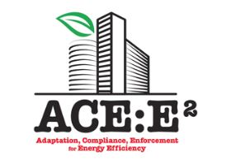

   

This project is funded by A project implemented by EXERGIA S.A., member

The European Union of SACO Consortium, in collaboration with PwC India

**The European Union’s programme for India**

# 2nd regional workshop to Implement Energy Conservation Building Code (ECBC) in India

**Place: Hotel ITC Kakatiya, Telengana, Hyderabad**

**Date: 28 August 2018**

**Speakers**

|  |  |
| --- | --- |
| **Name** | **Position / Company** |
| Mr. GSV Prasad | General Manager, Telangana State, Renewable Energy Development Corporation Ltd (TSREDCO) |
| Dr. Usha Ramachandra | Area Chair Person, Energy Area, Administrative Staff College of India (ASCI) |
| Mr. Saurabh Diddi | Director, Bureau of Energy Efficiency (BEE) |
| Mr. Arvind Kumar (IAS) | Principal Secretary, Municipal Administration & Urban Development Department, Government of Telangana |
| Mr. Pavan Kumar Parnandi | Consultant, TSREDCO |
| Assistant Prof. Raj Kiran | Administrative Staff College of India (ASCI) |
| Prof. Rajan Rawal | CEPT |
| Dr. Vishal Garg | IIIT Hyderabad |
| Mr. Rajeev Ralhan | PwC India |
| Mr. Kevin O’Rourke | European Expert |
| Mr. Tarun Garg | PwC India |

## Background

To improve the energy efficiency in the new commercial buildings, the Energy Conservation Building Code (ECBC) was created. ECBC was launched by the Ministry of Power (MoP), Government of India, in May 2007, as the first step towards promoting energy efficiency in the commercial building sector. The implementation of the code is expected to reduce energy demand in commercial buildings by 25% - 40%. The code can be amended by state governments as per their climatic conditions. The status of ECBC implementation in India is presented below.

|  |  |
| --- | --- |
| **STATUS NAME OF STATES** | |
| States that have notified the Code (12 states and 1 Union Territory (UT)) | Andhra Pradesh, Karnataka, Odisha, Punjab, Haryana, Rajasthan, Telangana, West Bengal, Uttarakhand, Puducherry (UT), Himachal Pradesh, Uttar Pradesh |
| States that have amended the code (18 States and 8 UT) | Kerala, Gujarat, Tamil Nadu, Maharashtra, Bihar, Madhya Pradesh and Delhi, Assam, Chhattisgarh, Jharkhand, Goa, Tripura, Arunachal Pradesh, Meghalaya, Nagaland, Mizoram, Manipur, Sikkim, Jammu & Kashmir, Chandigarh and UTs of Daman Diu, Lakshadweep, Andaman & Nicobar, Dadra & Nagar Haveli. |

The Code was created in 2007, however due to the following challenges it is still under the voluntary phase in most of the states. The list of challenges/barriers are:

* Inadequate awareness among the state officials, partial number of on-ground activities to implement the code are witnessed.
* Absence of common platform to share the experience of ECBC implementation and enforcement process.
* Absence of Standard action plan to implement ECBC in the state.

## The need

Gauging the acuteness of the challenges mentioned above, the Bureau of Energy Efficiency (BEE) in association with European Union (EU) launched a common implementation Forum for Energy Conservation Building Code (ECBC) in a national level workshop organized, on the 22nd of September 2017, in Hotel Taj Mahal, Man Singh Road, New Delhi.

The workshop was supported by EU within the framework of the “Clean Energy Cooperation with India" (CECI) programme, and in particular the ACE: E2 project (Adoption, Compliance, Enforcement for Energy Efficiency) which aims at providing legal and policy support to the development and implementation of energy efficiency legislation for the building sector in India, in collaboration with the Bureau of Energy Efficiency. The technical assistance for this ACE:E2 is being provided by PricewaterhouseCoopers India Private Limited and Exergia S.A (a Greece based consultancy firm).

The importance of creating regional level groups has been highlighted in order to ensure successful implementation of ECBC across various states of India. It has been proposed to create four regional level groups, viz. East, West, North and South. Each group will have at least one state that has notified and one state that has amended the code.

## Second regional workshop in southern region of India

The second regional workshop was organized in southern region of India on 28th August 2018. The list of participating states are:

Telangana

Andhra Pradesh

Karnataka

Tamil Nadu

Chhattisgarh

Kerala

Puducherry

Andaman & Nicobar Islands

Lakshadweep

Relevant officials from the following list of identified stakeholders were also attended the workshop:

1. Bureau of Energy Efficiency (DG and Director)
2. European Union Delegation to India
3. State Designated Agency of each state
4. All Urban Local Bodies (ULBs) from Telangana
5. Urban Development Department of each state
6. Works Department in Telangana
7. DISCOMs and Other relevant Government Departments
8. CREDAI
9. Third Party Assessors
10. Green Building Consultants

### Objective of the workshop

The overall objectives of the workshop are:

1. Notified states to present the status of ECBC implementation in their states.
2. To discuss on the status of various policy instruments like integration of ECBC in bye-laws, building approval process and schedule of rates (SOR).
3. To present an efficient operational mechanism to implement ECBC in the state.
4. To increase the capacity of various stakeholders and professionals in the states.
5. To discuss on various market instruments required for the implementation of ECBC.
6. To present success stories/lessons learnt in various states.
7. To discuss on challenges/drivers for ECBC implementation.

### Brief of First Regional Workshop

The first regional workshop was held on 19th May 2018 at Hotel Novotel, Pune with the kind support of BEE and MEDA. It was an interactive workshop with multiple sessions on the topics. There were representation of the various government departments like PWD, ULBs/Municipal corporations, CPWD, DISCOMS, SDAs of 7 states (falling in the region) along with the practicing architects and consultants, representation from builder associations like CREDAI. The key outcomes of the workshop were:

* The state experience was shared with other state for implementation approach
* The capacity building programs for specific stakeholder is to be designed and delivered
* More number of demo projects are identified and states volunteered their upcoming buildings to be ECBC compliant
* Approach for the ECBC clearances is discussed and the process is to be simplified
* The stakeholders should be equipped with the process of clearance and compliance and for the same the capacity building should be done.

## Inaugural session

The inaugural session started with the lamp lighting from all the honorable guests.

Following dignitaries graced the occasion with their kind presence and started the workshop with lamp lighting.

1. Mr. GSV Prasad – General Manager, Telengana State Renewable Energy Development Corporation Ltd (TSREDCO)
2. Mr. Saurabh Diddi – Director BEE, Minister of Power, Government of India
3. Dr. Usha Ramachandra – Area Chair Person, Energy Area, Administrative Staff College of India (ASCI)
4. Mr. Arvind Kumar (IAS) – Principal Secretary, Municipal Administration & Urban Development Department, Government of Telangana
5. Mr. Kevin O Rourke – European Expert on EPBD
6. Mr. Pawan Kumar Parnandi – Consultant, TSREDCO
7. Mr. Rajeev Ralhan – Director, PwC India
8. Asst. Prof. Raj Kiran – Administrative Staff College of India (ASCI)

All the dignitaries were felicitated on behalf of TSREDCO and PwC.

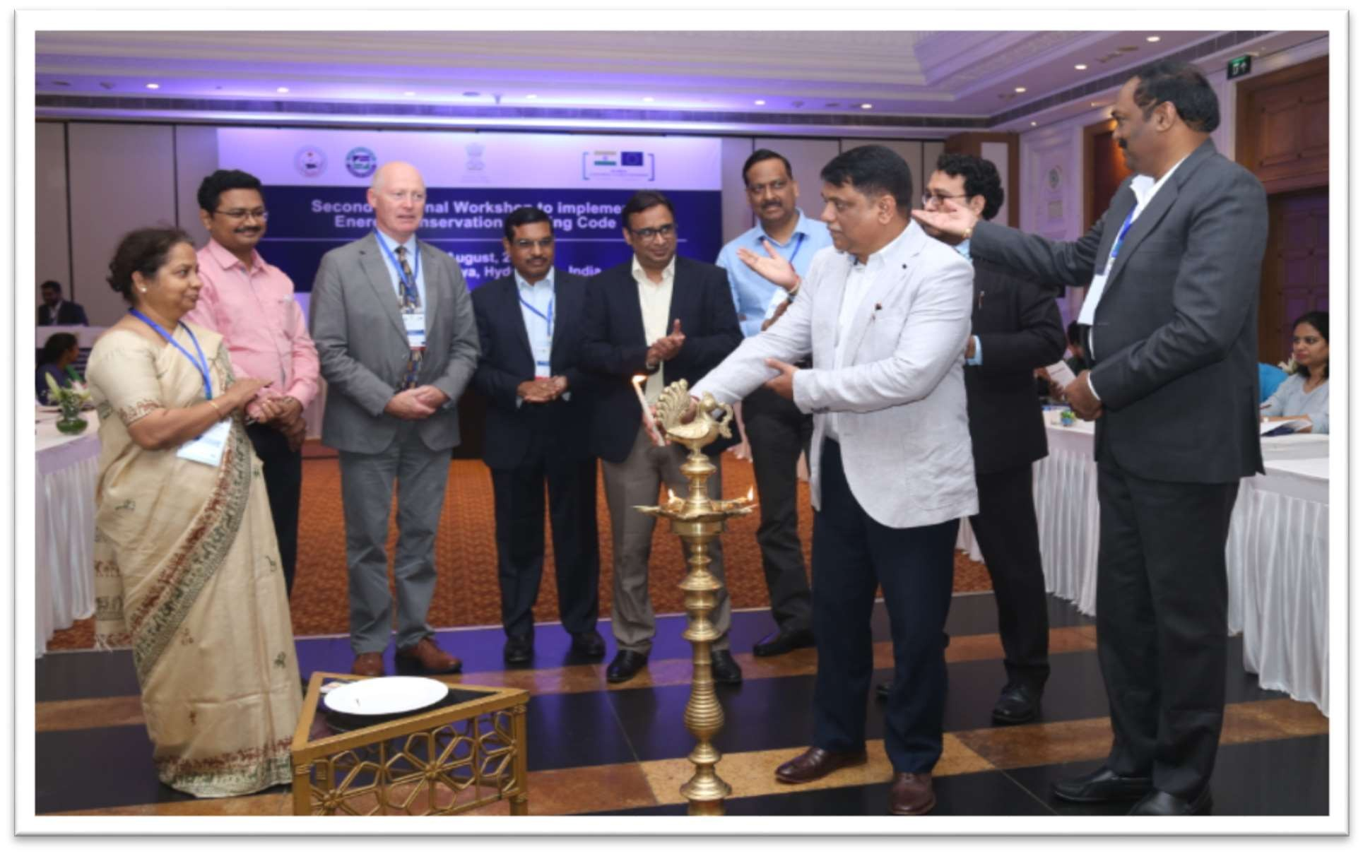

**Mr. GSV Prasad, General Manager of TSREDCO**, began the session welcoming all attendees on behalf of TSREDCO. He thanked PwC and EU for choosing Telangana state as host. He briefed about the background of EC ACT, ECBC 2007 and the need of this workshop. He added that the objective of the workshop is to comprehend the need of mandating ECBC in the states, proposed ECBC implementation mechanism and understanding the existing regulatory framework followed by ULB, electricity suppliers. The experts from BEE shall put forth the status of implementation of ECBC in India. EU and PwC will support us in overcoming the hinderance faced in the implementing ECBC in states, with their key inputs. He also presented the implementation model adopted by Telangana state. He briefly talked about the role of the government departments, SDA, implementation agency, third party assessors, technical committees formed for the proper implementation of ECBC. TSREDCO developed pool of experts of ECBC in association with ACSI with support of BEE and 100 people are now ECBC experts in the state. TSREDCO has identified 30 buildings as ECBC compliant with savings of 8% to 30% in Telangana state.

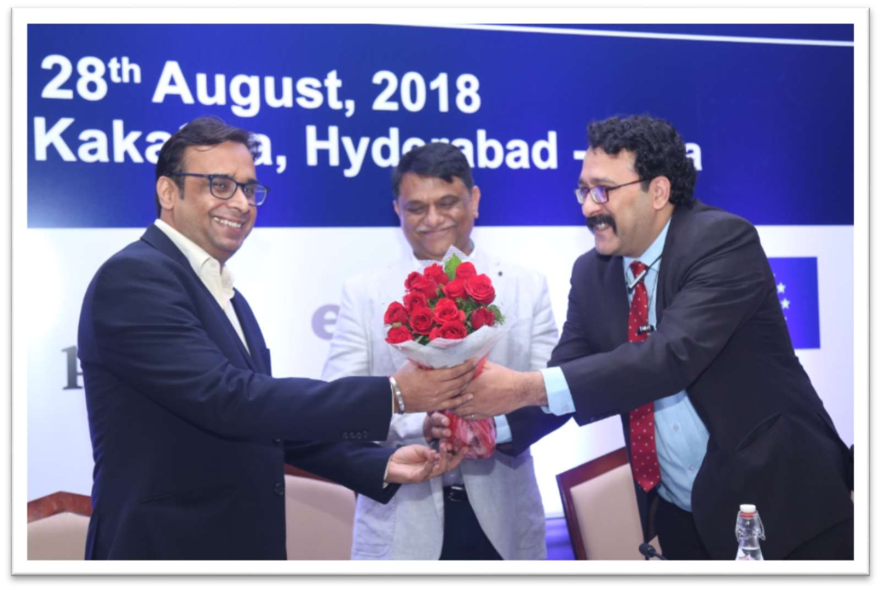

He welcomed and acknowledged the attendees from the private sector and other departments for their active participation in this workshop. He later thanked BEE and PwC for organising the workshop.

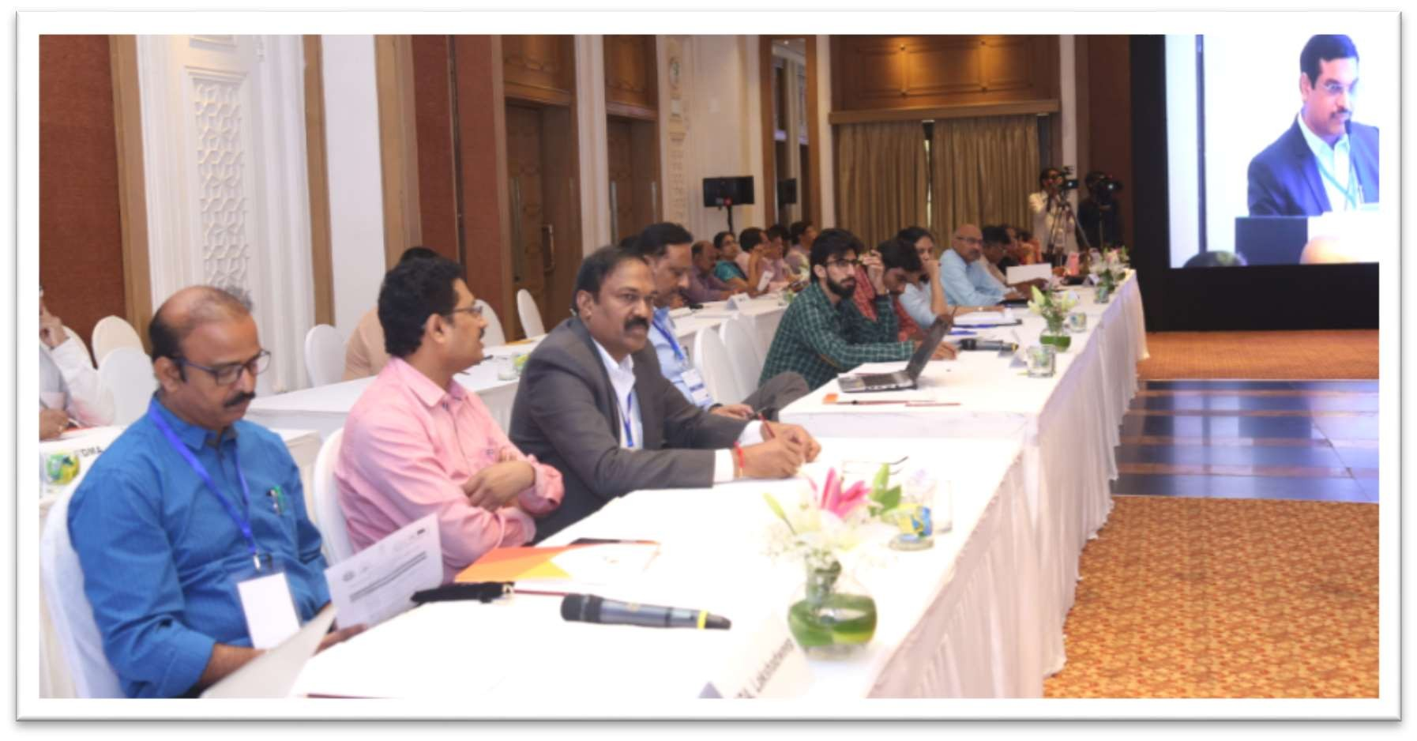

**Mr. Rajeev Ralhan** delivered the objective of the workshop. Firstly, he thanked Mr. Arvind Kumar (IAS) and other dignitaries on the head table. He talked about the challenges faced in India for the implementation of ECBC over the years and PwC approach towards the solution to these challenges. He briefed the agenda and idea behind the regional workshops. Under the umbrella of EU, PwC is working as implementing partner in four states. Since there are similar issues in each state, the idea was to create a common implementation forum where all the states come forward and share their views and learning. The first national workshop was held in September 2017, in Delhi with all the key stakeholders as participants. The design of the workshop is to have discussions on real problrems, share the experience and decide the right strategy.

The first regional workshop held in Maharashtra in May where 7 western states attended and interacted. The third one is scheduled in Bihar in next month and the national workshop will take place in February 2019. The forum will serve the purpose for all the building energy efficiency programs in India. He further requested Mr. Arvind Kumar, principal secretary, Municipal Administration & Urban Development Department, Government of Telangana to emphasize on synergies between the governmental departments in order to assist in the development of a common implementation forum where MOUD and MOP are working together for the implementation of ECBC.

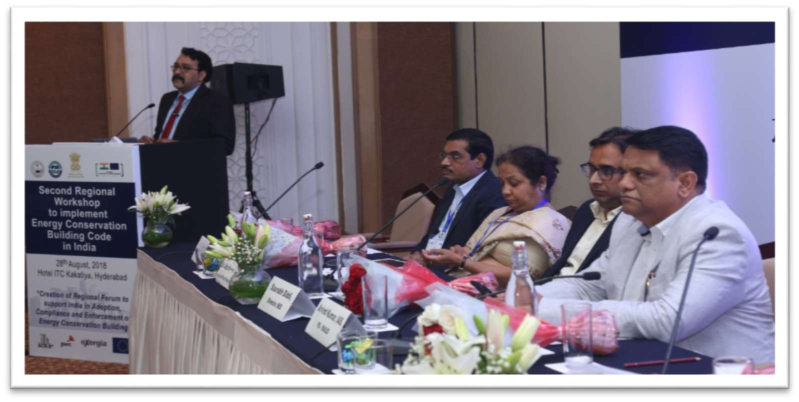

Lastly, he requested all to participate and contribute in the discussion rather than being a listener. CREDAI can also share their experience for the implementation of ECBC. He requested all to talk and learn on the practical experience. The whole idea is to interact in this forum. He ended up thanking BEE, ASCI and TSREDCO for helping and supporting for organizing this workshop.

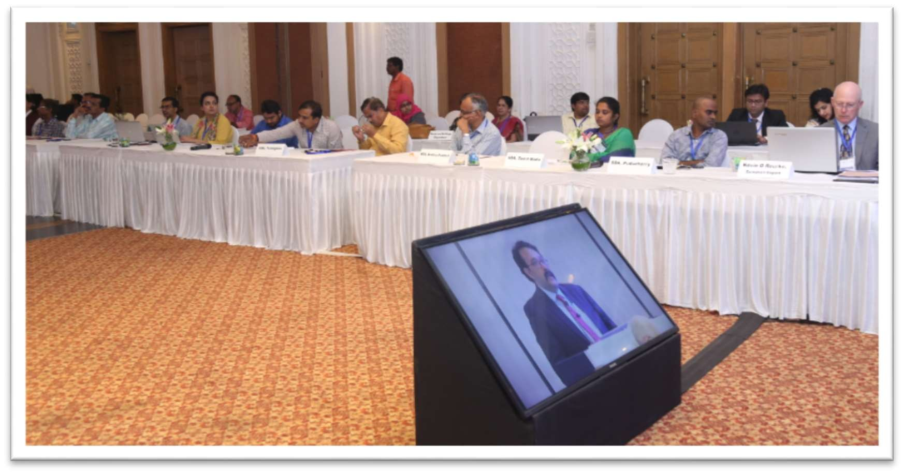

**Dr. Usha Ramachandra** delivered her notions on the workshop. She congratulated TSREDCO, MOUD and BEE to reach mandatory compliance of code in the state. She mentioned the role of ASCI, NDRC and IIIT Hyderabad in the framework of ECBC implementation in the state and support to the government. She briefly acknowledged architects, consultants, builders, R&B department. The R&B came up with the proposal to make the new integrated district collectorate complex as ECBC complaint building as a demonstration project. She mentioned that the recently opened IKEA store is also ECBC compliant at occupancy stage. She mentioned that ASCI has trained more than 700 professionals and created a pool of 100 ECBC experts in the state who are working towards the proper implementation of ECBC. She further added that ASCI will support the development of implementation path of ECBC 2017 in the state now.

**Mr. Saurabh Diddi** delivered the key note address. He congratulated Telangana for the efforts put in the ECBC implementation. He added the importance of Urban Development department and thanked Mr. Arvind Kumar for his kind presence in this workshop. Hyderabad (GHMC) is the only ULB to put this to implementation stage in India.

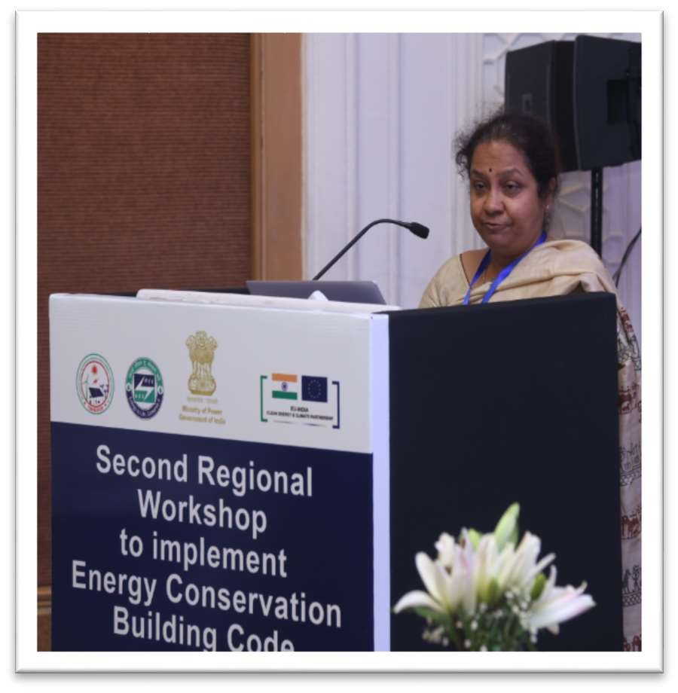

He added the role of the building design in achieving energy savings in buildings. He put forward the need of ECBC and status of the ECBC in India in front of the participants by presenting the current energy consumption facts in the country and the future needs for 2030, which are going to be around 6 times of the installed capacity of today. Further, he added the dependency of the country on the non-renewable sources of energy. He then linked climate change and energy consumption with the examples of thunderstorms and floods. India has signed in COP21 to reduce energy emission intensity by 30%-35% by 2030. Therefore, energy efficiency in building plays a significant role if we see the current and future growth in energy consumption. At national level, the group of secretaries recommended to have ECBC implement in all states of India by the end of this year. BEE is also working on energy efficiency in industries by PAT, labelling and standards, etc. He focused on the construction of energy efficient homes and buildings in the coming years.

Modern technologies in construction is also needed seeing the space requirements; ECBC can easily be fitted in the modern construction practices. He commented on the current status of ECBC in India and recently complied design stage building in UP as per ECBC 2017. The rules for ECBC was also circulated in January 2018 and these rules emphasize on the approach of adoption and implementation of ECBC in the state.

Lastly, he mentioned that if we start implementing ECBC today we can save 240 million tons of CO2 by 2030. So we need to implement ECBC as soon as possible. He further added that the procedural issues in the implementation process should be discussed between the states in order to share experience and knowledge.

**Mr. Arvind Kumar, IAS, Principal Secretary, Municipal Administration & Urban Development Department, Government of Telangana** welcomed the delegation and participants. He added that the Chief Minister himself is interested in energy efficiency in buildings. He thanked BEE and EU for the choosing Hyderabad to host the venue. RERA is going to be introduced in the state very soon and implementation will take place now. The ECBC implementation is one of the remarkable achievements for the state and he acknowledged contribution of builders in the adoption of the code. The central government wish to achieve India’s CO2 emissions by one third of current emissions by 2030 as a part of the Paris agreement. Therefore, it is needed to optimize energy usage in buildings as they are the main energy consuming sector. Hyderabad is also expecting new construction of approximately 40-50 million sqft in the coming years. He mentioned that they have provision of the building approval process, which is part of DPMS; an online process where all the ECBC compliance are checked and the approvals are given online. IKEA is one of the iconic buildings, which is setting the trends being a 4 star rated building.

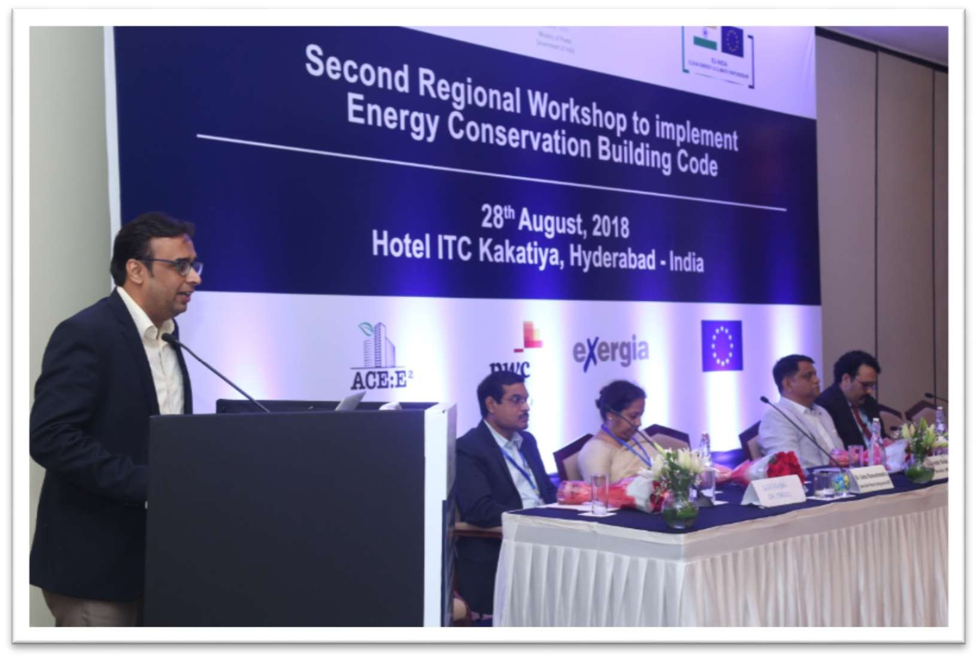

He added that Rajeev should discuss with DIPP (Department of Industrial promotion and policy) in order to have ECBC included in the ranking during next year. DIPP has certain criteria of evaluation. There are lot of buildings coming up in the industrial corridors where many Indian and MNC are planning to set up and all buildings should be energy efficient.

He further added the scenario in state that in 40 total TPAs and around 30 buildings are identified as ECBC compliant buildings. More than 700 officials and professionals have been trained. As a builder, he mentioned that he is aware on the commercial benefits that an ECBC compliant building could offer.

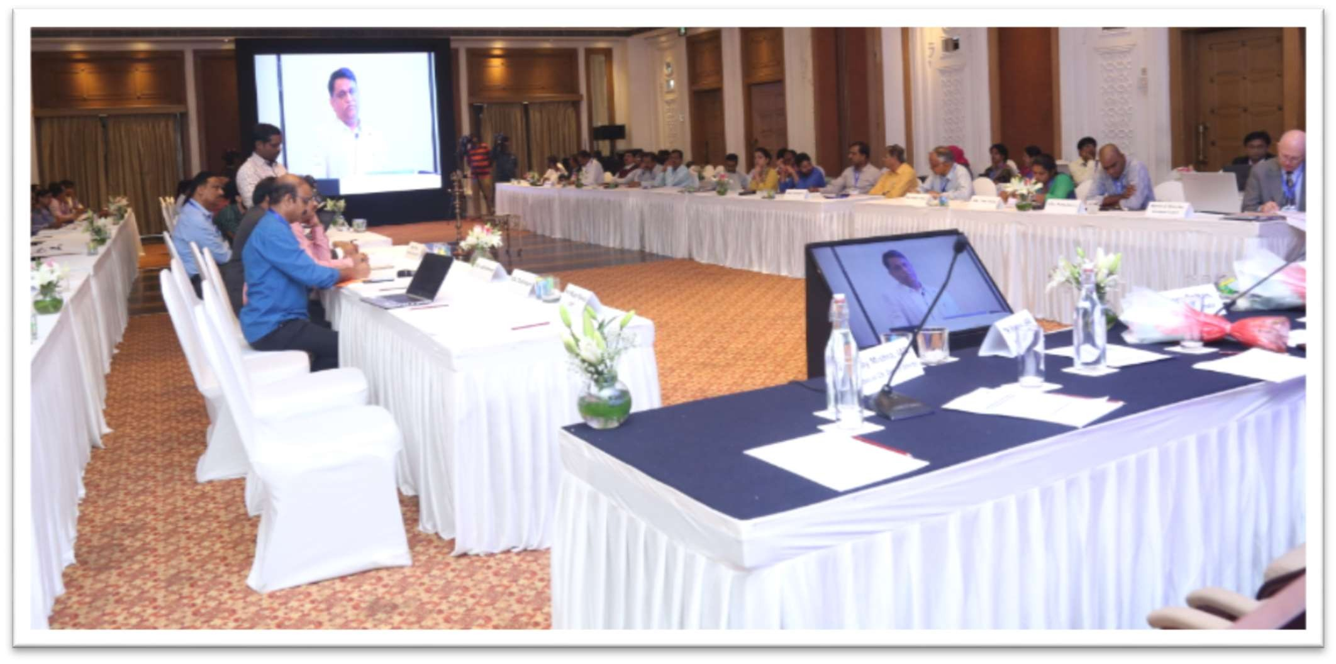

Vote of Thanks – Mr. Pawan Kumar

Pawan delivered vote of thanks to all the participants of the workshop and briefly discussed the agenda of the workshop. He requested all to participate in discussions so as to make the workshop fruitful for all.

